**Antique Gold Jewelled Star Wall Mirror**

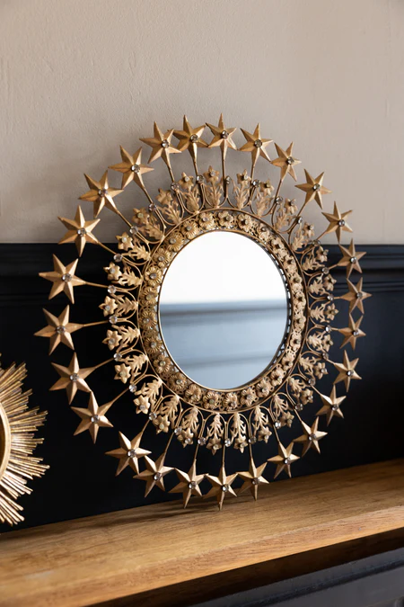The Antique Gold Jewelled Star Wall Mirror is a stunning decorative piece that combines opulence and celestial beauty. Featuring a star-shaped design, the frame is adorned with intricate jewel-like embellishments that catch the light, creating a sparkling effect. The antique gold finish adds a vintage charm and sophistication, making it a perfect statement piece for any room. Whether placed in the living room, entryway, or bedroom, this mirror's unique design enhances the space with its radiant elegance. A true blend of function and luxury, it not only serves as a mirror but also as a captivating piece of art for your wall.